Architectural Components - View

📝Definition
# Source: AI Source: Provided by: [Data Path: Persons Table -> ID Column: 1, Name_En Column: Motasem Essam] -> From: [ChatGPT] on [1/23/2026]
The View is the component responsible for displaying information to the user and receiving user input (via Controller or ViewModel).
👉 Think of the View as the face of the application — it shows data and captures user interactions.

🔑 Responsibilities of View
# Source: AI Source: Provided by: [Data Path: Persons Table -> ID Column: 1, Name_En Column: Motasem Essam] -> From: [ChatGPT] on [1/23/2026]
- Present data from the Model/ViewModel
- Capture user input (clicks, typing, gestures)
- Reflect changes in application state
- Minimize business logic (delegate to Service/ViewModel)

🧱 Example (MVC)
# Source: AI Source: Provided by: [Data Path: Persons Table -> ID Column: 1, Name_En Column: Motasem Essam] -> From: [ChatGPT] on [1/23/2026]
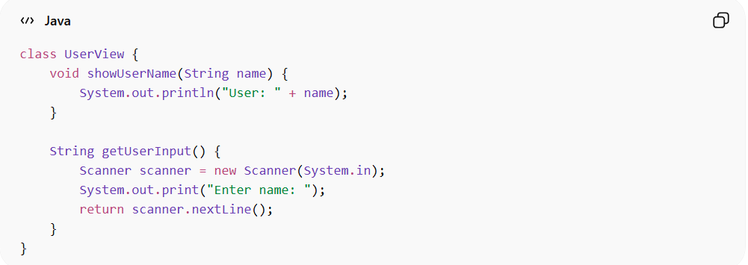
class UserView {
void showUserName(String name) {
System.out.println("User: " + name);
}

String getUserInput() {
Scanner scanner = new Scanner(System.in);
System.out.print("Enter name: ");
return scanner.nextLine();
}
}
👉 Here:
- UserView displays the user name
- Receives input from the user
- Does not contain business logic

❌ Bad Example (View Doing Too Much)
# Source: AI Source: Provided by: [Data Path: Persons Table -> ID Column: 1, Name_En Column: Motasem Essam] -> From: [ChatGPT] on [1/23/2026]
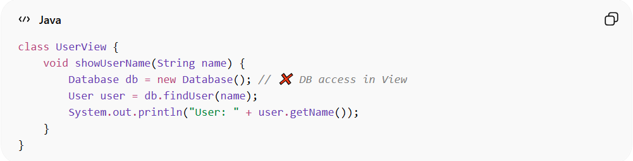
class UserView {
void showUserName(String name) {
Database db = new Database(); // ❌ DB access in View
User user = db.findUser(name);
System.out.println("User: " + user.getName());
}
}
👉 Problems:
- View is coupled to data source
- Violates separation of concerns
- Hard to test UI independently

✅ Good Example (Clean View)
# Source: AI Source: Provided by: [Data Path: Persons Table -> ID Column: 1, Name_En Column: Motasem Essam] -> From: [ChatGPT] on [1/23/2026]
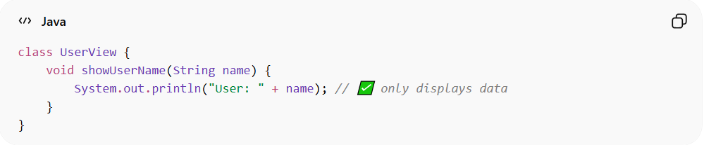
class UserView {
void showUserName(String name) {
System.out.println("User: " + name); // ✅ only displays data
}
}
👉 Benefits:
- UI only
- Can change presentation without affecting Model or Service
- Easier to mock for tests

🔄 View in Different Patterns
# Source: AI Source: Provided by: [Data Path: Persons Table -> ID Column: 1, Name_En Column: Motasem Essam] -> From: [ChatGPT] on [1/23/2026]
- MVC → View displays Model data and forwards input to Controller
- MVVM → View binds to ViewModel using data binding
- MVP → View interacts with Presenter

⚠️ Common Mistakes
# Source: AI Source: Provided by: [Data Path: Persons Table -> ID Column: 1, Name_En Column: Motasem Essam] -> From: [ChatGPT] on [1/23/2026]
- Adding business logic in View ❌
- Accessing database/API directly ❌
- Making View responsible for state management ❌

💡 Key Idea
# Source: AI Source: Provided by: [Data Path: Persons Table -> ID Column: 1, Name_En Column: Motasem Essam] -> From: [ChatGPT] on [1/23/2026]
View should only handle presentation and user interaction; all logic belongs elsewhere

🧾 Summary
# Source: AI Source: Provided by: [Data Path: Persons Table -> ID Column: 1, Name_En Column: Motasem Essam] -> From: [ChatGPT] on [1/23/2026]
View:
- Displays data to the user
- Captures user input
- Delegates logic to Controller/ViewModel
- Keeps the UI layer clean and testable

